ADMISSION GUIDE

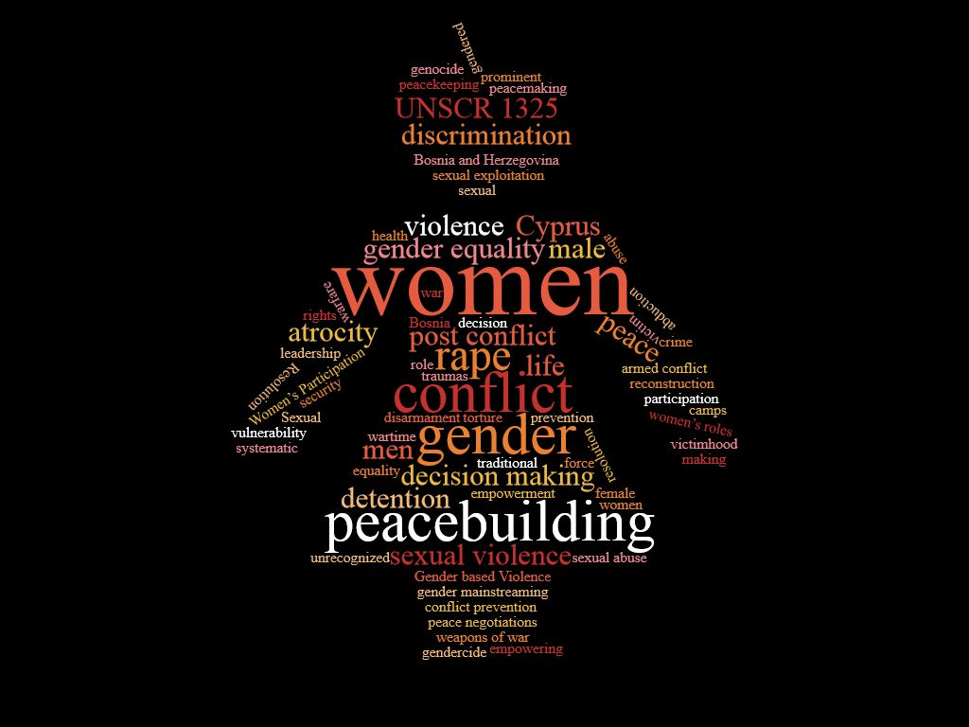

WINTER SCHOOL 2017

GENDER IN CONFLICT AND PEACEBUILDING

Organized by the International Association for Political Science Students (IAPSS) & hosted by Eastern Mediterranean University

Word of Welcome by the Organizing Committee

Dear Winter School Participant,

We are very glad you are reading this guide and will be joining us in Cyprus very soon. As the organizing committee, we had plenty of fun planning this event, starting with the concept, choosing the beautiful destination in Famagusta and finally breaking the theme down to topics that are current, contested and interesting for students of the discipline. Although it is impossible to grasp the all gender issues in a winter school or even a semester at the university, we tried as much as we can to make this school cater to every need you might have. Lectures and Q&A sessions serve to widen your horizons about a certain topic, the workshops gives you tools with which you can put this knowledge to the test while working groups give you autonomy to create your own focus points and develop a small scale project from A to Z with the guidance of both lectures and workshops. To provide a good break for the purely academic programme we have planned a day trip so that you have the opportunity to have some hands-on experience. Taking part in an intercultural event is a precious and enlightening experience, and we are happy that you chose our winter school in Famagusta to do so. This winter school may even be the start of an interesting research project, a discovery of a hidden passion or a newfound career path. It will also be a great asset for future applications to conferences, workshops and study programs.
We hope we can deliver on our part by providing you with the just right balance of academic and fun, and are very excited to be getting to know you all very soon!

Your organizing committee

Kristian Xavier Carrera Kurjenoja
Kateryna Dyshkantyuk
Pawel Pustelnik
Serap Aydemir

About IAPSS

The International Association for Political Science Students (IAPSS) is the worldwide representation of undergraduate and graduate students of political science, international relations and related studies. IAPSS strives to deliver a sustainable academic contribution to the education of its members, to foster exchange among young political scientists across the globe and to promote social and scientific responsibility. We do this by offering a multiplicity of events, publications, and professionalization and career services as well as lobbying for political science student’s interests on the international level. The general aim is to provide a platform for academically strong students and enable them to pursue fast-track career in academia. IAPSS embraces more than 1.500 members from over 100 countries.
The Association was founded in 1998 in Leiden (the Netherlands) and is exclusively student-led, non-profit run and politically independent. The IAPSS Headquarters is currently located in Nijmegen (the Netherlands) and hosted by Radboud University Nijmegen, IAPSS’ premium partner and itself a leading institution in the political science arena in Europe.
Our portfolio and annual agenda provided with great dedication to our members is built up around three pillars. In each pillar, we conceptualize and realize activities, projects and services that contribute to the academic, personal and social development of our members worldwide 365 days all year long.
IAPSS’ unique international network of individual members and member association enables us to influence debates, initiatives and scientific developments internationally. More nearly 250,000 individuals are following IAPSS through different social media devices and regular consultations are taking place with all international partners in the field of political science. You want to become actively involved? Feel free to get in contact with the committee on-site to get more information on our work. We will also offer an exclusive session during the winter school, which will present you the association in further detail.

Find out more at: www.iapss.org

Organizing Committee

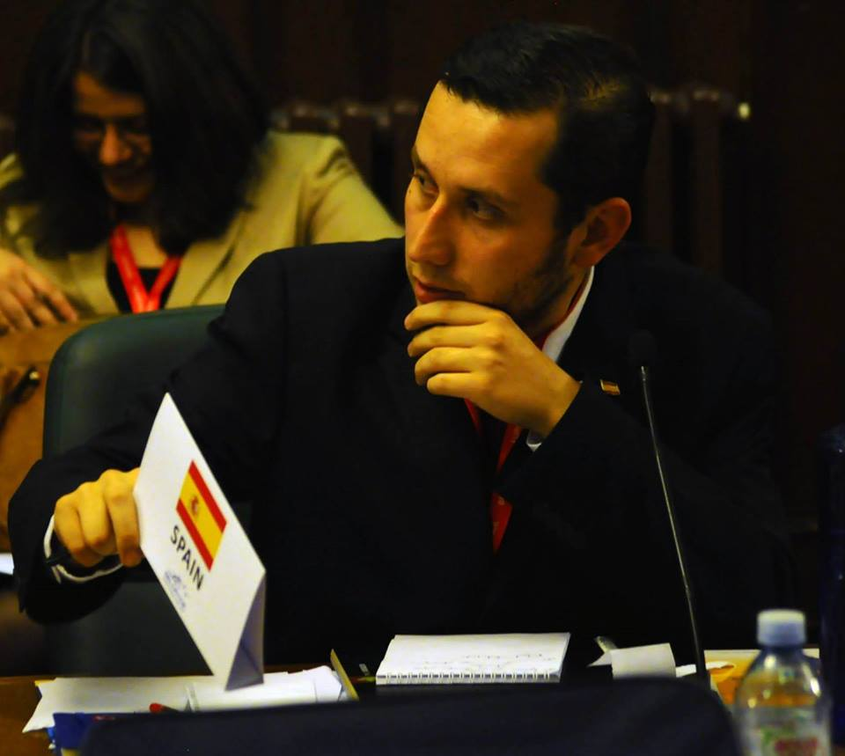
Educated in the areas of Social Anthropology and International Relations at the undergraduate, Xavier has a first level MA in Political Science granted by the Universities of Belgrade and Graz and a second one in Democracy and Human Rights – which was granted by the Universities of Bologna and Sarajevo. He has performed fieldwork in Serbia, Bosnia-Herzegovina, Croatia, Macedonia and Montenegro. Nowadays Xavier works for the EU Rule of Law Mission in Kosovo (EULEX). More specifically on the Strengthening Division which is concerned on monitoring, mentoring and advising Kosovo's institutions such as the Ministry of Justice, Ministry of Interior, Border Police and the Supreme Court.
His main research interests are diversity management and the political systems of the Western Balkans. Some of his research findings have been already published in international academic journals."

Kristian Xavier Carrera Kurjenoja e-mail: events@iapss.org
IAPSS Head of Events

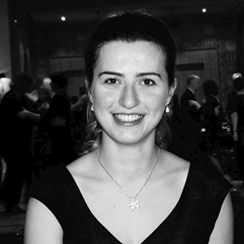
Kateryna was born in Kiev, Ukraine and moved at the age of 14 to Germany. Currently, she is finishing her Bachelor’s degree in Philosophy and Political Science at the University of Bremen with a specialization in Ethics and Political Philosophy. Her thesis focuses on Humanitarian Interventions and Just War Theory. Kateryna has spent an Erasmus semester at the Pantheon-Sorbonne University in Paris. Her mother tongues are Ukrainian and Russian; she speaks fluently German and English and is improving her French. Besides of her academic interests she has been always widely involved in different kinds of voluntary activities. Since 2013 Kateryna has regularly taken part in academic conferences and events organized by IAPSS.

Kateryna Dyshkantyuk e-mail: finances@iapss.org
Treasurer

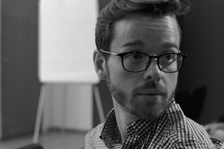
Dr Pawel Pustelnik graduated from his PhD Programme at Cardiff University in 2016 and is currently part-time teaching at Cardiff as well as working for an NGO dealing with education. He graduated from Social Science Research Methods Masters at Cardiff University and Masters in Global Environmental Governance at Free University in Amsterdam. He also studied International Relations and Diplomacy (BA) at Wroclaw University, Wyszynski University in Warsaw and La Sapienza in Rome. Pawel has extensively worked with various student-led organisations: Ecumenical Youth Council in Europe, Religions for Peace Youth Network as well as International Young Naturefriends and others. In his research he is looking at the EU policy-making. Previously he has been working on issues related to bio-patents and US regulations concerning agriculture. Pawel is fluent in English, Polish and Italian. He is also doing fairly well in German and French. If he is not busy, he is usually running, cooking or playing violin or piano.
Pawel Pustelnik e-mail: winterschool2@iapss.org
Study Trip Coordinator

Serap Aydemir is currently a Joint MA Candidate in South-Eastern European Studies at the Universities of Belgrade and Graz. During her master’s studies, she worked as a student research assistant at the Centre for Southeast European Studies in Graz. Prior to her graduate studies, she volunteered for migrant and refugee youth in Salzburg for a year. She holds a BA in Business Administration from the University of Marmara and during her bachelors; she spent one semester in Germany. She is aspiring to pursue a PhD after she is done with her masters. Her research interests include State-and Nation-building, Identity Politics and Conflict, Ethnicity and Nationalism, Politicization of Religion, Everyday Nationalism, Genocide and Mass Violence, Gender and Minority Rights. Serap speaks Turkish, English and German. She is also very eager to improve her Serbo-Croatian. She joined IAPSS to organize the Winter School 2017 and really enjoys working in collaboration with other dedicated IAPSS board members.

Serap Aydemir e-mail: winterschool@iapss.org
Seasonal Schools Coordinator

Program components

The Winter School will feature highly interactive teaching formats and joint sessions, which aim in their variety to enable excellent conditions for collective and individual learning progress. Most sessions will feature problem-based approaches and case studies, while others deal with theoretical and methodological content. Our general aim is to provide you with eight full-days of input and let you experience the addressed topic from multiple angles.

Obligatory Program Components

All program components are obligatory. There will be general sessions at the beginning and end of the program. These sessions will provide you with general knowledge on the concept of the program. We will also use it to present you our organization. For those who want to become active within IAPSS, we will offer an optional IAPSS talk. We will start with a kick-off, group interviews to break the ice and will end with a wrap-up session.

Lectures

The core of our program is the lectures and the Q&A sessions after. We invited five speakers who will each deliver a presentation of each subtopic. These lectures are mainly based on case studied and research the speakers are conducting. All lectures should last for one and a half hours and be followed by a discussion and Q&A to leave room for interaction. All lecturers expect the participants to do the readings prior to the lecture day.

Working Group Meetings

Another core of our school features extensive group work. These sessions are mandatory. These meetings will primarily use the diverse academic background of the participants and enable space for exchange and discussion while working on a joint project to be presented at the end of the Winter School. More details will be provided under the Working Groups title.

Documentary Screenings

A fruitful combination of socializing and food for thoughts: A documentary screening. We will watch three selected documentaries and use the possibility to discuss them with each other and our facilitators.

Working Groups

Submitting your applications, all of you were asked to mark your working group preferences. Each subtopic is assigned to a working group made up of 7 participants. The aim of the working group is to gather people with the same interests in the same topic. The coordinators on-site will help you find a project idea, which you can follow throughout the week. Our coordinators, lectures and workshops conductors will provide you with guidance.

The working group is the third pillar of the Winter School next to the lectures and the workshops. In the lectures, you will mainly be getting information from the speaker with a chance to ask questions and engage in discussions. The workshops will serve to use the input of the lectures in order to provide you with academic tools with which you can put that knowledge into practice by creating a project, a research paper, or simply a presentation for your working groups.
The working group will use both the lectures and the workshops to give you complete autonomy in developing an idea from A to Z and coming up with an end product on the last day of the Winter School. As mentioned, the product can be a short research paper on the specific topic you chose that you can carry on after the school, whether individually or with the same group of people, and which can be published in IAPSS flagship journal POLITIKON. It can also be a project idea that you can also carry on after the program, maybe at your university or institution, or it can be a presentation by your group on a certain topic.

Transportation

From airports to EMU Campus:

If you are flying into Larnaca airport, you need to take a taxi.
If you are flying into Ercan airport, you can either take a KIBHAS bus, which will bring you directly to the campus, or you can take a taxi.

EMU also provides airport transportation service. The prices regarding EMU’s pick up service are listed below. If you would like to use EMU’s transportation service, you should get in touch with Özgür Taşçıoğlu. Her e-mail address: ozgur.tascioglu@emu.edu.tr

From ERCAN airport to EMU campus:

For one person: 90 TL
For 2 people: 75 TL (per person)
For 3 people: 50 TL (per person)
For 4 and more person: 30 TL (per person)

From LARNACA airport to EMU campus:

For one person: 200 TL
For 2 people: 90 TL (per person)
For 3 and more people: 60 TL (per person)

Inner-city transportation

For the local transportation, you can benefit from university transportation services. For more information, please visit the following page. https://ww1.emu.edu.tr/en/campus/transportation/728

Accommodation

EMU Dormitory Conditions

- The name of the dormitory that participants will be staying during the Winter School is HOMEDORM.

- Participants should bring all their personal cleaning equipments (e.g. towel, shampoo, soap, hairdryer etc.)

- There is laundry room available in the dormitory where you can wash and also iron your clothes.

- There is a kitchen available where you can cook whenever you wish, but you should have your own dishware and cutlery. There is a supermarket on the first floor of the dormitory, if you would like to buy dishes, you can buy from there or you can bring them with you.

- A receptionist will always be at the reception during the day, so you can check in anytime during the day. But during the night there will only be a security guard around. Therefore, participants, who will arrive in Cyprus after midnight, should inform us about their late arrival in advance. In such a case, the receptionist will be waiting for you after midnight. If you going to arrive late, please get in touch with Özgür Taşcıoğlu from EMU international office ozgur.tascioglu@emu.edu.tr and please do not forget to include Serap winterschool@iapss.org in the CC.

- For more information, please visit the following page: http://dormitories.emu.edu.tr/en/dormitories/bot-and-other/home-dorm

Some photos of the dormitory are available below.

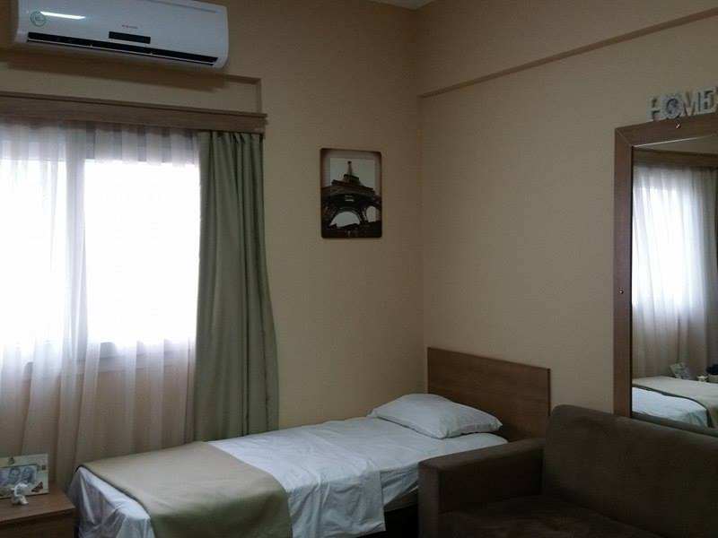
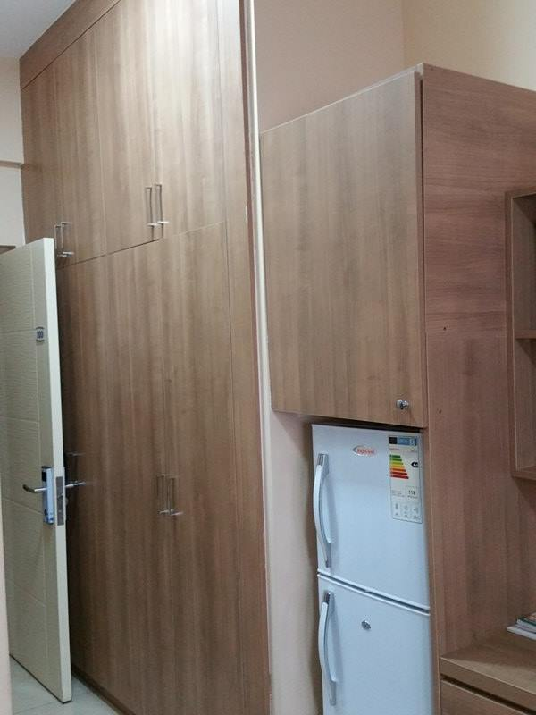
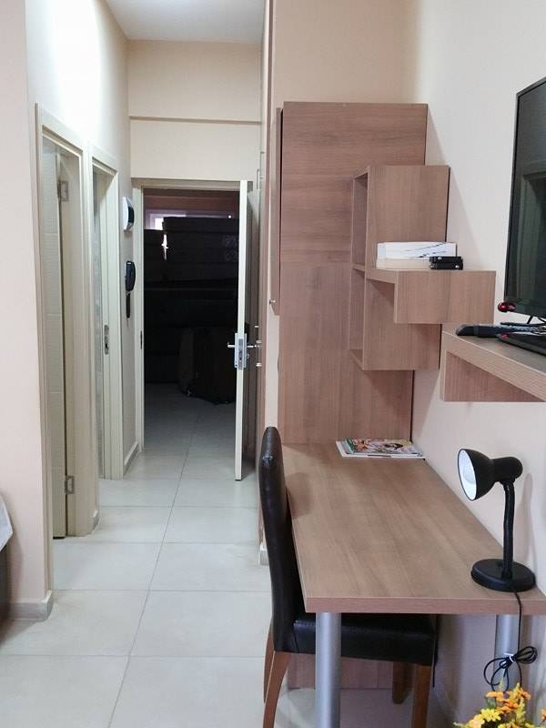

Eating on Campus
Hours and prices:
Breakfast: Tabledot Restaurant 07:30 -10:00, Price: 7 TL
Lunch: Tabledot Restaurant 11:30 -14:00 Price 11 TL / Tower Restaurant 12:00-14:00, Price: 15-25 TL
Dinner: Tabledot Restaurant 17:00- 20:30, Price: 11 TL

Dress Code

The dress code for the Winter School is smart casual. No need for suits and ties. But if you would like to be dressier for the Welcome and Goodbye dinners, then it is better to bring some smart dresses as well.

